Table of Contents

Device Tree 详解 1

1、DTS语法 2

1.1、标准Property 3

1.1.1、compatible 4

1.1.2、model 4

1.1.3、phandle 4

1.1.4、#address-cells 、 #size-cells 6

1.1.5、reg 7

1.1.6、ranges 7

1.1.7、interrupt property 8

1.2、标准Node 12

1.2.1、Root node 12

1.2.2、/aliases node 13

1.2.3、/memory node 13

1.2.4、/chosen node 14

1.2.5、/cpus node 14

2、DTB 20

2.1、DTB的编译 20

2.2、DTB的文件结构 21

2.3、Bootloader对DTB的传递 22

3、Kernel解析 23

3.1、DTB解析 23

3.1.1 setup_machine_fdt() 23

3.1.2 unflatten_device_tree() 24

3.2、Device创建 31

3.2.1 of_platform_populate() 31

3.2.2 mt_i2c_driver 36

3.2.3 mz_mag_driver 44

# Device Tree 详解

# 1、DTS语法

对于DeviceTree的来历和用处大部分人都已经非常了解了，DeviceTree发源于PowerPC架构，为了消除代码中冗余的各种device注册代码而产生的，现在已经成为了linux的通用机制。

DeviceTree的结构非常简单，由两种元素组成：Node(节点)、Property(属性)。下图是一个真实的简单的DeviceTree树形结构图。

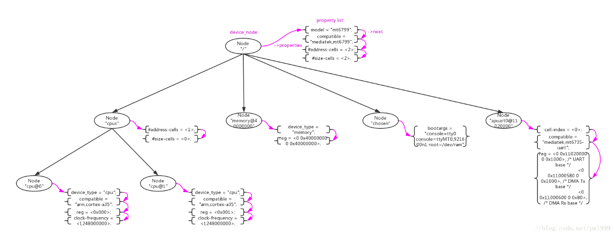

* Node节点。在DTS中使用一对花括号"node-name{}"来定义;
* Property属性。在Node中使用"property-name=value"字符串来定义；

/ {

model = "mt6799";

compatible = "mediatek,mt6799";

interrupt-parent = <&gic>;

#address-cells = <2>;

#size-cells = <2>;

/* chosen */

chosen {

bootargs = "console=tty0 console=ttyMT0,921600n1 root=/dev/ram";

};

}

上述例子中定义了一个根节点"/"和一个子节点“chosen”，其他的字符串“model = “mt6799”;”、“compatible = “mediatek,mt6799”;”都是property。

Node、Property的名字和值都是可以自定义的，没有太大限制。但是DeviceTree的标准还是预定义了一些标准的Node和Property，在标准Node和Property之间还定义了一些约束规则。关于这些描述在 The DeviceTree Specification官方spec中有详细描述。这里为了方便大家，还是重复做一些搬运。

## 1.1、标准Property

Property的格式为"property-name=value"，其中value的取值类型如下：

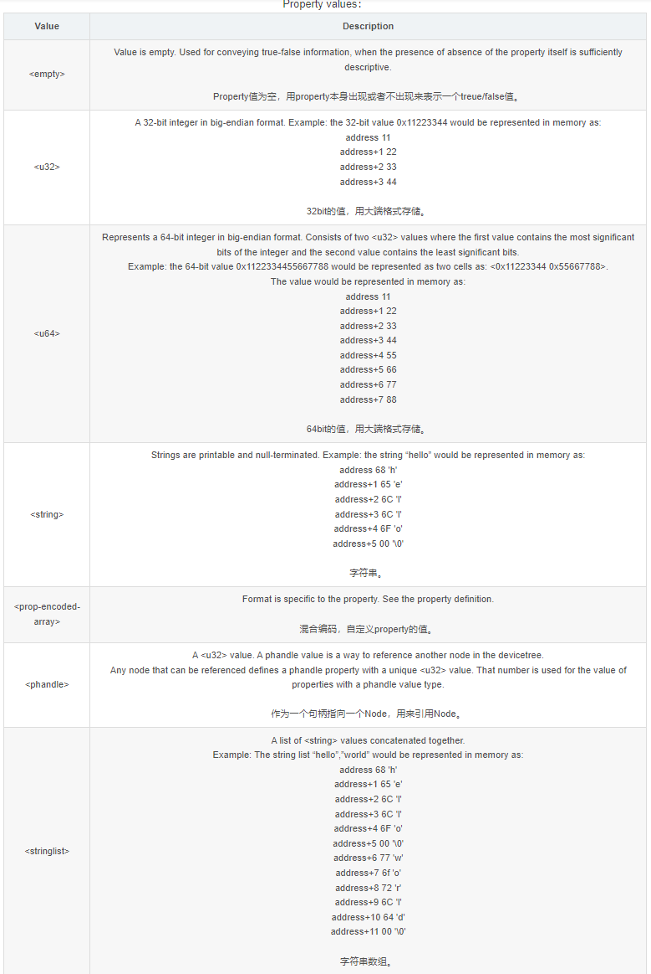

### 1.1.1、compatible

“compatible"属性通常用来device和driver的适配，推荐的格式为"manufacturer,model”。

### 1.1.2、model

"model"属性只是简单的表示型号，root节点用其来传递值给machine_desc_str。

### 1.1.3、phandle

"phandle"属性通用一个唯一的id来标识一个Node，在property可以使用这个id来引用Node。

在DeviceTree中通过另一种方式进行phandle的定义和引用更加常见：

定义一个“label：”来引用Node，在编译是系统会自动为node生成一个phandle属性。“cpu0"是一个label，用来引用node"cpu@0”：

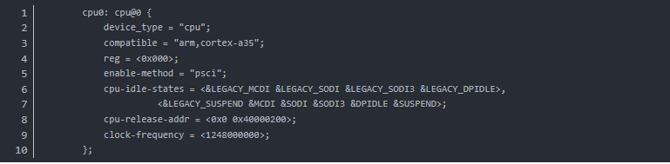

使用"&“来引用“label”，即是引用phandle。property"cpu"通过”&cpu0"来对node"cpu@0"：

### 1.1.4、#address-cells 、 #size-cells

"#address-cells, #size-cells"属性用来定义当前node的子node中"reg"属性的解析格式。

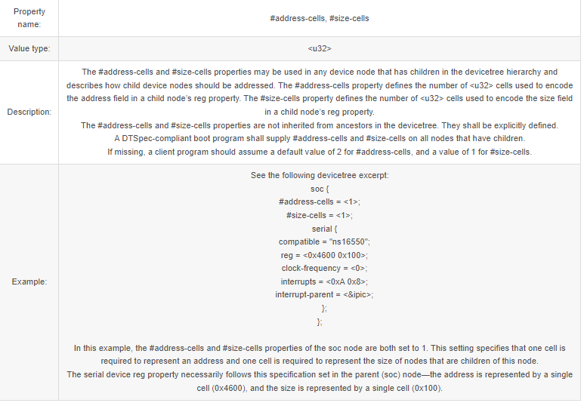

举例说明：

1、如果node"soc"中"#address-cells=<1>"、"#size-cells=<1>"，那么子node"serial"中"reg"属性的解析为“addr1 = 0x0, size1 = 0x100, addr2 = 0x0, size2 = 0x200”：

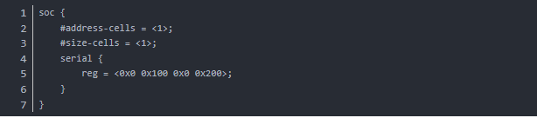

2、如果node"soc"中"#address-cells=<2>"、"#size-cells=<2>"，那么子node"serial"中"reg"属性的解析为“addr1 = 0x100, size1 = 0x200”：

3、如果node"soc"中"#address-cells=<2>"、"#size-cells=<0>"，那么子node"serial"中"reg"属性的解析为“addr1 = 0x100, addr2 = 0x200”：

### 1.1.5、reg

“reg"属性解析出"address,length"数字，解析格式依据父节点的”#address-cells、#size-cells"定义。

### 1.1.6、ranges

"ranges"属性用来做当前node和父node之间的地址映射，格式为(child-bus-address, parentbus-address, length)。其中child-bus-address的解析长度受当前node的#address-cells属性控制，parentbus-address的解析长度受父node的#address-cells属性控制length的解析长度受当前node的#size-cells属性控制。

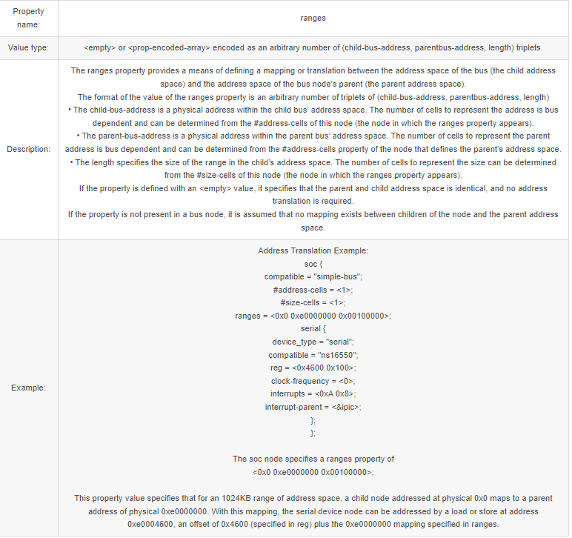

### 1.1.7、interrupt property

和中断相关的node可以分成3种：

“Interrupt Generating Devices”，中断发生设备，这种设备可以发生中断。

“Interrupt Controllers”，中断控制器，处理中断。

“Interrupt Nexus”，中断联结，路由中断给中断控制器。

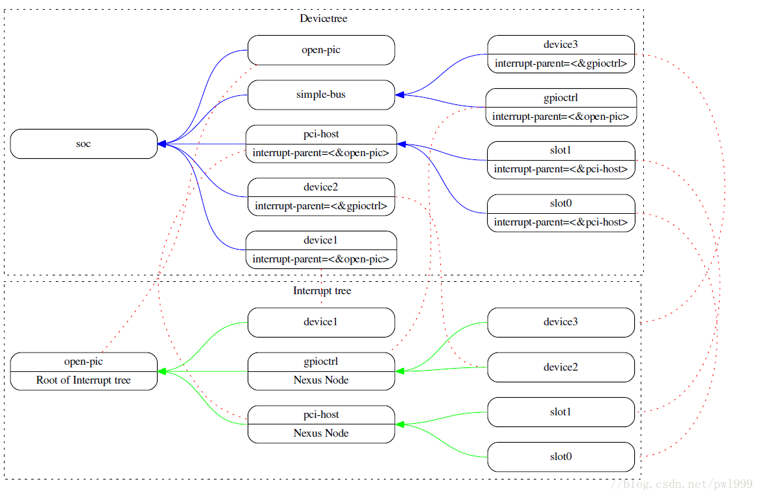

#### 1.1.7.1、Interrupt Generating Devices Property

"interrupts"属性用来定义设备的中断解析，根据其"interrupt-parent"node中定义的“#interrupt-cells”来解析。比如#interrupt-cells=2，那根据2个cells为单位来解析"interrupts"属性。

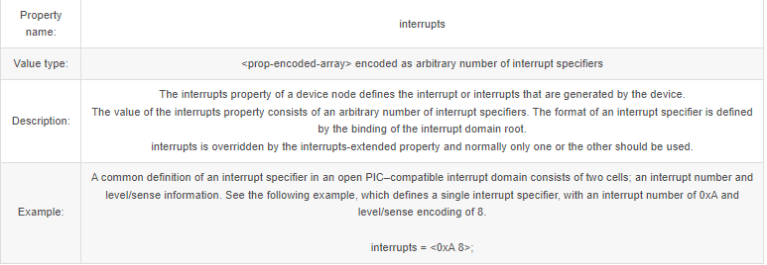

"interrupt-parent"属性用来制定当前设备的Interrupt Controllers/Interrupt Nexus，phandle指向对应的node。

Property name: interrupt-parent Value type: <phandle> Description: Because the hierarchy of the nodes in the interrupt tree might not match the devicetree, the interrupt-parent property is available to make the definition of an interrupt parent explicit. The value is the phandle to the interrupt parent. If this property is missing from a device, its interrupt parent is assumed to be its devicetree parent.

#### 1.1.7.2、Interrupt Controllers Property

"#interrupt-cells"属性用来规定连接到该中断控制器上的设备的"interrupts"属性的解析长度。

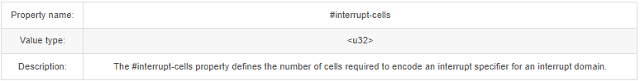

"interrupt-controller"属性用来声明当前node为中断控制器。

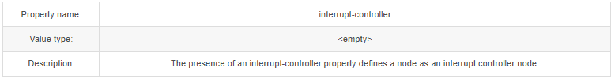

#### 1.1.7.3、Interrupt Nexus Property

"#interrupt-cells"属性用来规定连接到该中断控制器上的设备的"interrupts"属性的解析长度。

"interrupt-map"属性用来描述interrupt nexus设备对中断的路由。解析格式为5元素序列“child unit address, child interrupt specifier, interrupt-parent, parent unit address, parent interrupt specifier”。

其中：

“child unit address”的cells长度由子节点的“#address-cells”指定；

“child interrupt specifier”的cells长度由子节点的“#interrupt-cells”指定；

“interrupt-parent”phandle指向interrupt controller的引用；

“parent unit address”的cells长度由父节点的“#address-cells”指定；

“parent interrupt specifier”的cells长度由父节点的“#interrupt-cells”指定；

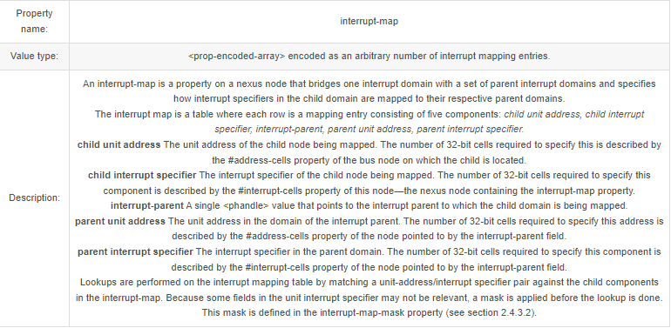

举例：

soc {

compatible = "simple-bus";

#address-cells = <1>;

#size-cells = <1>;

open-pic {

clock-frequency = <0>;

interrupt-controller;

#address-cells = <0>;

#interrupt-cells = <2>;

};

pci {

#interrupt-cells = <1>;

#size-cells = <2>;

#address-cells = <3>;

interrupt-map-mask = <0xf800 0 0 7>;

interrupt-map = <

/* IDSEL 0x11 - PCI slot 1 */

0x8800 0 0 1 &open-pic 2 1 /* INTA */

0x8800 0 0 2 &open-pic 3 1 /* INTB */

0x8800 0 0 3 &open-pic 4 1 /* INTC */

0x8800 0 0 4 &open-pic 1 1 /* INTD */

/* IDSEL 0x12 - PCI slot 2 */

0x9000 0 0 1 &open-pic 3 1 /* INTA */

0x9000 0 0 2 &open-pic 4 1 /* INTB */

0x9000 0 0 3 &open-pic 1 1 /* INTC */

0x9000 0 0 4 &open-pic 2 1 /* INTD */

>;

};

};

• For example, the first row of the interrupt-map table specifies the mapping for INTA of slot . The components of that row are shown here

child unit address: 0x8800 0 0

child interrupt specifier: 1

interrupt parent: &open-pic

parent unit address: (empty because #address-cells = <0> in the open-pic node)

parent interrupt specifier: 2 1

## 1.2、标准Node

Node Name常常由两部分组成“node-name@unit-address”，主要是为了防止Node Name重复冲突：

"node-name"是node的名字；

"unit-address"是node中“reg”属性描述的开始地址；

例如："msdc@11240000"中node-name=“msdc”，unit-address=“11240000”。

/ {

model = "mt6799";

compatible = "mediatek,mt6799";

interrupt-parent = <&gic>;

#address-cells = <2>;

#size-cells = <2>;

msdc0:msdc@11240000 {

compatible = "mediatek,msdc";

reg = <0x0 0x11240000 0x0 0x10000

0x0 0x10000e84 0x0 0x2>; /* FPGA PWR_GPIO, PWR_GPIO_EO */

interrupts = <GIC_SPI 79 IRQ_TYPE_LEVEL_LOW>;

};

下面主要介绍一下一些预先定义的标准Node。

### 1.2.1、Root node

每个DeviceTree只有一个根节点。根节点需要有以下必备属性：

Root Node Properties

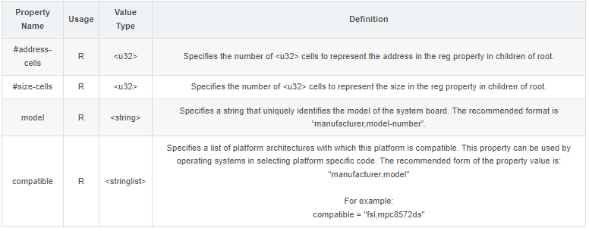

### 1.2.2、/aliases node

用来给一些绝对路径定义别名：

aliases {

serial0 = "/simple-bus@fe000000/serial@llc500";

ethernet0 = "/simple-bus@fe000000/ethernet@31c000";

};

### 1.2.3、/memory node

用来传递内存布局：

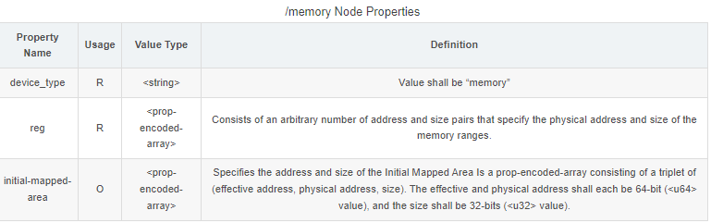

举例：

• RAM: starting address 0x0, length 0x80000000 (2GB)

• RAM: starting address 0x100000000, length 0x100000000 (4GB)

\ {

#address-cells = <2>;

#size-cells = <2>;

memory@0 {

device_type = "memory";

reg = <0x000000000 0x00000000 0x00000000 0x80000000

0x000000001 0x00000000 0x00000001 0x00000000>;

};

}

### 1.2.4、/chosen node

其中“bootargs”属性用来传递cmdline参数，“stdout-path”属性用来指定标准输出设备，“stdin-path”属性用来指定标准输入设备。

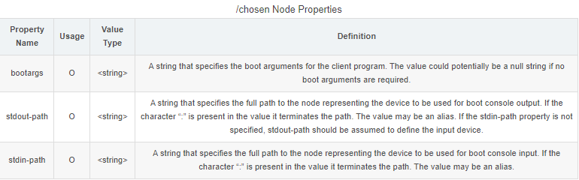举例：

/* chosen */

chosen {

bootargs = "console=tty0 console=ttyMT0,921600n1 root=/dev/ram";

};

### 1.2.5、/cpus node

/cpus节点也是必须的，下面举个具体例子：

cpus {

#address-cells = <1>;

#size-cells = <0>;

cpu0: cpu@0 {

device_type = "cpu";

compatible = "arm,cortex-a35";

reg = <0x000>;

enable-method = "psci";

cpu-idle-states = <&LEGACY_MCDI &LEGACY_SODI &LEGACY_SODI3 &LEGACY_DPIDLE>,

<&LEGACY_SUSPEND &MCDI &SODI &SODI3 &DPIDLE &SUSPEND>;

cpu-release-addr = <0x0 0x40000200>;

clock-frequency = <1248000000>;

};

cpu1: cpu@001 {

device_type = "cpu";

compatible = "arm,cortex-a35";

reg = <0x001>;

enable-method = "psci";

cpu-idle-states = <&LEGACY_MCDI &LEGACY_SODI &LEGACY_SODI3 &LEGACY_DPIDLE>,

<&LEGACY_SUSPEND &MCDI &SODI &SODI3 &DPIDLE &SUSPEND>;

cpu-release-addr = <0x0 0x40000200>;

clock-frequency = <1248000000>;

};

cpu2: cpu@002 {

device_type = "cpu";

compatible = "arm,cortex-a35";

reg = <0x002>;

enable-method = "psci";

cpu-idle-states = <&LEGACY_MCDI &LEGACY_SODI &LEGACY_SODI3 &LEGACY_DPIDLE>,

<&LEGACY_SUSPEND &MCDI &SODI &SODI3 &DPIDLE &SUSPEND>;

cpu-release-addr = <0x0 0x40000200>;

clock-frequency = <1248000000>;

};

cpu3: cpu@003 {

device_type = "cpu";

compatible = "arm,cortex-a35";

reg = <0x003>;

enable-method = "psci";

cpu-idle-states = <&LEGACY_MCDI &LEGACY_SODI &LEGACY_SODI3 &LEGACY_DPIDLE>,

<&LEGACY_SUSPEND &MCDI &SODI &SODI3 &DPIDLE &SUSPEND>;

cpu-release-addr = <0x0 0x40000200>;

clock-frequency = <1248000000>;

};

cpu4: cpu@100 {

device_type = "cpu";

compatible = "arm,cortex-a53";

reg = <0x100>;

enable-method = "psci";

cpu-idle-states = <&LEGACY_MCDI &LEGACY_SODI &LEGACY_SODI3 &LEGACY_DPIDLE>,

<&LEGACY_SUSPEND &MCDI &SODI &SODI3 &DPIDLE &SUSPEND>;

cpu-release-addr = <0x0 0x40000200>;

clock-frequency = <1378000000>;

};

cpu5: cpu@101 {

device_type = "cpu";

compatible = "arm,cortex-a53";

reg = <0x101>;

enable-method = "psci";

cpu-idle-states = <&LEGACY_MCDI &LEGACY_SODI &LEGACY_SODI3 &LEGACY_DPIDLE>,

<&LEGACY_SUSPEND &MCDI &SODI &SODI3 &DPIDLE &SUSPEND>;

cpu-release-addr = <0x0 0x40000200>;

clock-frequency = <1378000000>;

};

cpu6: cpu@102 {

device_type = "cpu";

compatible = "arm,cortex-a53";

reg = <0x102>;

enable-method = "psci";

cpu-idle-states = <&LEGACY_MCDI &LEGACY_SODI &LEGACY_SODI3 &LEGACY_DPIDLE>,

<&LEGACY_SUSPEND &MCDI &SODI &SODI3 &DPIDLE &SUSPEND>;

cpu-release-addr = <0x0 0x40000200>;

clock-frequency = <1378000000>;

};

cpu7: cpu@103 {

device_type = "cpu";

compatible = "arm,cortex-a53";

reg = <0x103>;

enable-method = "psci";

cpu-idle-states = <&LEGACY_MCDI &LEGACY_SODI &LEGACY_SODI3 &LEGACY_DPIDLE>,

<&LEGACY_SUSPEND &MCDI &SODI &SODI3 &DPIDLE &SUSPEND>;

cpu-release-addr = <0x0 0x40000200>;

clock-frequency = <1378000000>;

};

cpu8: cpu@200 {

device_type = "cpu";

compatible = "arm,cortex-a73";

reg = <0x200>;

enable-method = "psci";

cpu-idle-states = <&LEGACY_MCDI &LEGACY_SODI &LEGACY_SODI3 &LEGACY_DPIDLE>,

<&LEGACY_SUSPEND &MCDI &SODI &SODI3 &DPIDLE &SUSPEND>;

cpu-release-addr = <0x0 0x40000200>;

clock-frequency = <1638000000>;

};

cpu9: cpu@201 {

device_type = "cpu";

compatible = "arm,cortex-a73";

reg = <0x201>;

enable-method = "psci";

cpu-idle-states = <&LEGACY_MCDI &LEGACY_SODI &LEGACY_SODI3 &LEGACY_DPIDLE>,

<&LEGACY_SUSPEND &MCDI &SODI &SODI3 &DPIDLE &SUSPEND>;

cpu-release-addr = <0x0 0x40000200>;

clock-frequency = <1638000000>;

};

cpu-map {

cluster0 {

core0 {

cpu = <&cpu0>;

};

core1 {

cpu = <&cpu1>;

};

core2 {

cpu = <&cpu2>;

};

core3 {

cpu = <&cpu3>;

};

};

cluster1 {

core0 {

cpu = <&cpu4>;

};

core1 {

cpu = <&cpu5>;

};

core2 {

cpu = <&cpu6>;

};

core3 {

cpu = <&cpu7>;

};

};

cluster2 {

core0 {

cpu = <&cpu8>;

};

core1 {

cpu = <&cpu9>;

};

};

};

idle-states {

entry-method = "arm,psci";

LEGACY_MCDI: legacy-mcdi {

compatible = "arm,idle-state";

arm,psci-suspend-param = <0x0000001>;

entry-latency-us = <600>;

exit-latency-us = <600>;

min-residency-us = <1200>;

};

LEGACY_SODI: legacy-sodi {

compatible = "arm,idle-state";

arm,psci-suspend-param = <0x0000002>;

entry-latency-us = <600>;

exit-latency-us = <600>;

min-residency-us = <1200>;

};

LEGACY_SODI3: legacy-sodi3 {

compatible = "arm,idle-state";

arm,psci-suspend-param = <0x0000003>;

entry-latency-us = <600>;

exit-latency-us = <600>;

min-residency-us = <1200>;

};

LEGACY_DPIDLE: legacy-dpidle {

compatible = "arm,idle-state";

arm,psci-suspend-param = <0x0000004>;

entry-latency-us = <600>;

exit-latency-us = <600>;

min-residency-us = <1200>;

};

LEGACY_SUSPEND: legacy-suspend {

compatible = "arm,idle-state";

arm,psci-suspend-param = <0x0000005>;

entry-latency-us = <600>;

exit-latency-us = <600>;

min-residency-us = <1200>;

};

MCDI: mcdi {

compatible = "arm,idle-state";

arm,psci-suspend-param = <0x0010001>;

entry-latency-us = <600>;

exit-latency-us = <600>;

min-residency-us = <1200>;

};

SODI: sodi {

compatible = "arm,idle-state";

arm,psci-suspend-param = <0x1010002>;

entry-latency-us = <800>;

exit-latency-us = <1000>;

min-residency-us = <2000>;

};

SODI3: sodi3 {

compatible = "arm,idle-state";

arm,psci-suspend-param = <0x1010003>;

entry-latency-us = <800>;

exit-latency-us = <1000>;

min-residency-us = <2000>;

};

DPIDLE: dpidle {

compatible = "arm,idle-state";

arm,psci-suspend-param = <0x1010004>;

entry-latency-us = <800>;

exit-latency-us = <1000>;

min-residency-us = <2000>;

};

SUSPEND: suspend {

compatible = "arm,idle-state";

arm,psci-suspend-param = <0x1010005>;

entry-latency-us = <800>;

exit-latency-us = <1000>;

min-residency-us = <2000>;

};

};

};

# 2、DTB

## 2.1、DTB的编译

DTB(Devicetree Blob)是DTS的二进制文件格式，Kernel使用DTC工具将DTS源文件编译成DTB，bootloader再将DTB文件传递给Kernel解析。

不遵守标准书写的DTS文件在编译的时候会报错。

## 2.2、DTB的文件结构

DTB文件的结构如上图所示，主要在3部分：

struct ftd_header。文件头结构；

structure block。存放含Node和Property的Value；

strings block。存放Property的Name；把Property Name单独分为一个区域的原因是，有很多Property Name是重复的，单独一个区域可以使用指针引用，节约空间。

dtb中的fdt_header的数据结构：

struct fdt_header {

uint32_t magic;

uint32_t totalsize;

uint32_t off_dt_struct;

uint32_t off_dt_strings;

uint32_t off_mem_rsvmap;

uint32_t version;

uint32_t last_comp_version;

uint32_t boot_cpuid_phys;

uint32_t size_dt_strings;

uint32_t size_dt_struct;

};

dtb中node header的数据结构：

struct fdt_node_header {

fdt32_t tag;

char name[0]; // node name 存放在structure block

};

dtb中property header的数据结构：

struct fdt_property {

fdt32_t tag;

fdt32_t len;

fdt32_t nameoff; // perperty name存放在strings block

char data[0];

};

整个文件使用5种token来分割出node和property：

FDT_BEGIN_NODE (0x00000001)

FDT_END_NODE (0x00000002)

FDT_PROP (0x00000003)

FDT_NOP (0x00000004)

FDT_END (0x00000009)

可以使用hex编辑器来查看DTB文件的结构：

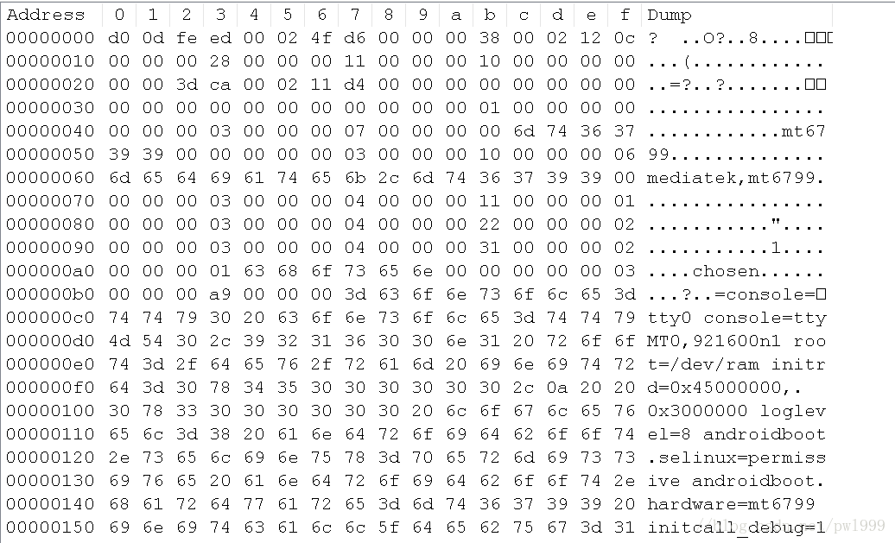

## 2.3、Bootloader对DTB的传递

没有仔细去看

# 3、Kernel解析

## 3.1、DTB解析

### 3.1.1 setup_machine_fdt()

直接在dtb中解析根节点的一些属性和子节点给系统早期使用。

解析"/"节点的model"属性给machine_desc赋值；

解析"/chosen"node中的"bootargs"属性给boot_command_line；

解析"/“节点的”#size-cells"、"#address-cells"属性；

解析"/memory"node中的"reg"属性，并将memory区域加入到系统；

start_kernel() -> setup_arch() -> setup_machine_fdt():

↓

static void __init setup_machine_fdt(phys_addr_t dt_phys)

{

/* (1) 映射dtb内存，到使之可以访问 */

void *dt_virt = fixmap_remap_fdt(dt_phys);

/* (2) 早期扫描device tree中的一些node和property */

if (!dt_virt || !early_init_dt_scan(dt_virt)) {

pr_crit("\n"

"Error: invalid device tree blob at physical address %pa (virtual address 0x%p)\n"

"The dtb must be 8-byte aligned and must not exceed 2 MB in size\n"

"\nPlease check your bootloader.",

&dt_phys, dt_virt);

while (true)

cpu_relax();

}

/* (3) 使用device tree中root node的"model/compatible"属性给machine_desc赋值 */

machine_desc_set(of_flat_dt_get_machine_name());

dump_stack_set_arch_desc("%s (DT)", of_flat_dt_get_machine_name());

}

↓

bool __init early_init_dt_scan(void *params)

{

bool status;

/* (2.1)校验dtb数据 */

status = early_init_dt_verify(params);

if (!status)

return false;

/* (2.2) */

early_init_dt_scan_nodes();

return true;

}

↓

void __init early_init_dt_scan_nodes(void)

{

/* (2.2.1) 解析"/chosen"node中的"bootargs"属性 */

/* Retrieve various information from the /chosen node */

of_scan_flat_dt(early_init_dt_scan_chosen, boot_command_line);

/* (2.2.2) 解析"/"node中的"#size-cells"、"#address-cells"属性 */

/* Initialize {size,address}-cells info */

of_scan_flat_dt(early_init_dt_scan_root, NULL);

/* (2.2.3) 解析"/memory"node中的"reg"属性，并将memory区域加入到系统 */

/* Setup memory, calling early_init_dt_add_memory_arch */

of_scan_flat_dt(early_init_dt_scan_memory, NULL);

}

↓

early_init_dt_scan_memory() -> early_init_dt_add_memory_arch() -> memblock_add()

### 3.1.2 unflatten_device_tree()

将DTB完全解析为内核使用的的device_node、property结构：

start_kernel() -> setup_arch() -> unflatten_device_tree():

↓

void __init unflatten_device_tree(void)

{

/* (1) 解析dtb数据到kernel中 */

__unflatten_device_tree(initial_boot_params, &of_root,

early_init_dt_alloc_memory_arch);

/* (2) 扫描"/aliases"、"/chosen"节点来进行一些预制值的配置 */

/* Get pointer to "/chosen" and "/aliases" nodes for use everywhere */

of_alias_scan(early_init_dt_alloc_memory_arch);

}

↓

static void __unflatten_device_tree(const void *blob,

struct device_node **mynodes,

void * (*dt_alloc)(u64 size, u64 align))

{

unsigned long size;

int start;

void *mem;

pr_debug(" -> unflatten_device_tree()\n");

if (!blob) {

pr_debug("No device tree pointer\n");

return;

}

pr_debug("Unflattening device tree:\n");

pr_debug("magic: %08x\n", fdt_magic(blob));

pr_debug("size: %08x\n", fdt_totalsize(blob));

pr_debug("version: %08x\n", fdt_version(blob));

if (fdt_check_header(blob)) {

pr_err("Invalid device tree blob header\n");

return;

}

/* (1.1) 第一遍扫描，计算dtb解析需要的内存空间 */

/* First pass, scan for size */

start = 0;

size = (unsigned long)unflatten_dt_node(blob, NULL, &start, NULL, NULL, 0, true);

size = ALIGN(size, 4);

pr_debug(" size is %lx, allocating...\n", size);

/* (1.2) 分配所需内存 */

/* Allocate memory for the expanded device tree */

mem = dt_alloc(size + 4, __alignof__(struct device_node));

memset(mem, 0, size);

*(__be32 *)(mem + size) = cpu_to_be32(0xdeadbeef);

pr_debug(" unflattening %p...\n", mem);

/* (1.3)第二遍扫描，在分配的内存中创建device_node、property树形结构来存储dtb的解析 */

/* Second pass, do actual unflattening */

start = 0;

unflatten_dt_node(blob, mem, &start, NULL, mynodes, 0, false);

if (be32_to_cpup(mem + size) != 0xdeadbeef)

pr_warning("End of tree marker overwritten: %08x\n",

be32_to_cpup(mem + size));

pr_debug(" <- unflatten_device_tree()\n");

}

↓

static void * unflatten_dt_node(const void *blob,

void *mem,

int *poffset,

struct device_node *dad,

struct device_node **nodepp,

unsigned long fpsize,

bool dryrun)

{

const __be32 *p;

struct device_node *np;

struct property *pp, **prev_pp = NULL;

const char *pathp;

unsigned int l, allocl;

static int depth;

int old_depth;

int offset;

int has_name = 0;

int new_format = 0;

/* (1.1.1) 解析node，解析node中的name值 */

pathp = fdt_get_name(blob, *poffset, &l);

if (!pathp)

return mem;

allocl = ++l; /* l 为当前路径的长度 */

/* version 0x10 has a more compact unit name here instead of the full

* path. we accumulate the full path size using "fpsize", we'll rebuild

* it later. We detect this because the first character of the name is

* not '/'.

*/

if ((*pathp) != '/') {

new_format = 1;

if (fpsize == 0) {

/* root node: special case. fpsize accounts for path

* plus terminating zero. root node only has '/', so

* fpsize should be 2, but we want to avoid the first

* level nodes to have two '/' so we use fpsize 1 here

*/

fpsize = 1;

allocl = 2;

l = 1;

pathp = "";

} else {

/* account for '/' and path size minus terminal 0

* already in 'l'

*/

fpsize += l; /* 当前full path的长度 = 上一次full path的长度 + 当前node nam的长度 l */

allocl = fpsize;

}

}

/* 计算解析当前node节点需要的内存大小 = device_node + full path */

np = unflatten_dt_alloc(&mem, sizeof(struct device_node) + allocl,

__alignof__(struct device_node));

/* dryrun = true，只进行长度计算

dryrun = fasle，进行实际的赋值 */

if (!dryrun) {

char *fn;

of_node_init(np);

np->full_name = fn = ((char *)np) + sizeof(*np); /* device_node->full_name，指向device_node结构体的结尾 */

if (new_format) {

/* rebuild full path for new format */

if (dad && dad->parent) {

/* 先拷入上次的full name */

strcpy(fn, dad->full_name);

#ifdef DEBUG

if ((strlen(fn) + l + 1) != allocl) {

pr_debug("%s: p: %d, l: %d, a: %d\n",

pathp, (int)strlen(fn),

l, allocl);

}

#endif

fn += strlen(fn);

}

/* 再加上 '/' */

*(fn++) = '/';

}

/* 最后加上当前node的name */

memcpy(fn, pathp, l);

prev_pp = &np->properties;

/* node和node之间树形结构的创建 */

if (dad != NULL) {

np->parent = dad;

np->sibling = dad->child;

dad->child = np;

}

}

/* (1.1.2) 解析node中的property */

/* process properties */

for (offset = fdt_first_property_offset(blob, *poffset);

(offset >= 0);

(offset = fdt_next_property_offset(blob, offset))) {

const char *pname;

u32 sz;

/* 解析一个property：

p：property中的data

pname：property的name指针，实际存储位置在dt_strings区域中

sz：property data的长度

*/

if (!(p = fdt_getprop_by_offset(blob, offset, &pname, &sz))) {

offset = -FDT_ERR_INTERNAL;

break;

}

if (pname == NULL) {

pr_info("Can't find property name in list !\n");

break;

}

if (strcmp(pname, "name") == 0)

has_name = 1;

/* 计算解析当前property的内存大小 = property */

pp = unflatten_dt_alloc(&mem, sizeof(struct property),

__alignof__(struct property));

/* 实际的property赋值 */

if (!dryrun) {

/* We accept flattened tree phandles either in

* ePAPR-style "phandle" properties, or the

* legacy "linux,phandle" properties. If both

* appear and have different values, things

* will get weird. Don't do that. */

/* 如果property为"phandle"，设置父node的device_node->phandle为当前属性的值 */

if ((strcmp(pname, "phandle") == 0) ||

(strcmp(pname, "linux,phandle") == 0)) {

if (np->phandle == 0)

np->phandle = be32_to_cpup(p);

}

/* And we process the "ibm,phandle" property

* used in pSeries dynamic device tree

* stuff */

if (strcmp(pname, "ibm,phandle") == 0)

np->phandle = be32_to_cpup(p);

/* 给property的其他字段赋值：（DTB的空间没有释放，被property成员指针引用）

property->name：指针指向dtb strings blcok区域中的属性name

property->length：属性data的长度

property->value：指针指向dtb stucture block区域中的属性data

*/

pp->name = (char *)pname;

pp->length = sz;

pp->value = (__be32 *)p;

*prev_pp = pp;

prev_pp = &pp->next;

}

}

/* with version 0x10 we may not have the name property, recreate

* it here from the unit name if absent

*/

if (!has_name) {

const char *p1 = pathp, *ps = pathp, *pa = NULL;

int sz;

while (*p1) {

if ((*p1) == '@')

pa = p1;

if ((*p1) == '/')

ps = p1 + 1;

p1++;

}

if (pa < ps)

pa = p1;

sz = (pa - ps) + 1;

pp = unflatten_dt_alloc(&mem, sizeof(struct property) + sz,

__alignof__(struct property));

if (!dryrun) {

pp->name = "name";

pp->length = sz;

pp->value = pp + 1;

*prev_pp = pp;

prev_pp = &pp->next;

memcpy(pp->value, ps, sz - 1);

((char *)pp->value)[sz - 1] = 0;

pr_debug("fixed up name for %s -> %s\n", pathp,

(char *)pp->value);

}

}

/* 根据"name"、 "device_type"属性，来给device_node结构中的name、type成员赋值 */

if (!dryrun) {

*prev_pp = NULL;

np->name = of_get_property(np, "name", NULL);

np->type = of_get_property(np, "device_type", NULL);

if (!np->name)

np->name = "<NULL>";

if (!np->type)

np->type = "<NULL>";

}

/* (1.1.3)如果还有子node的存在，递归解析 */

old_depth = depth;

*poffset = fdt_next_node(blob, *poffset, &depth);

if (depth < 0)

depth = 0;

while (*poffset > 0 && depth > old_depth)

mem = unflatten_dt_node(blob, mem, poffset, np, NULL,

fpsize, dryrun);

if (*poffset < 0 && *poffset != -FDT_ERR_NOTFOUND)

pr_err("unflatten: error %d processing FDT\n", *poffset);

/*

* Reverse the child list. Some drivers assumes node order matches .dts

* node order

*/

if (!dryrun && np->child) {

struct device_node *child = np->child;

np->child = NULL;

while (child) {

struct device_node *next = child->sibling;

child->sibling = np->child;

np->child = child;

child = next;

}

}

if (nodepp)

*nodepp = np;

return mem;

}

## 3.2、Device创建

### 3.2.1 of_platform_populate()

首先root节点下的第1级子节点创建成platform device。

对root节点下的第1级子节点，如果有"compatible"属性创建对应platform device；

如果"compatible"属性等于of_default_bus_match_table(“simple-bus”/“simple-mfd”/“arm,amba-bus”)中任意一种，继续对其子节点进行platform device创建。

start_kernel() -> ... ->do_initcalls() -> arm64_device_init():

↓

const struct of_device_id of_default_bus_match_table[] = {

{ .compatible = "simple-bus", },

{ .compatible = "simple-mfd", },

#ifdef CONFIG_ARM_AMBA

{ .compatible = "arm,amba-bus", },

#endif /* CONFIG_ARM_AMBA */

{} /* Empty terminated list */

};

static int __init arm64_device_init(void)

{

if (of_have_populated_dt()) {

of_iommu_init();

of_platform_populate(NULL, of_default_bus_match_table,

NULL, NULL);

} else if (acpi_disabled) {

pr_crit("Device tree not populated\n");

}

return 0;

}

↓

int of_platform_populate(struct device_node *root,

const struct of_device_id *matches,

const struct of_dev_auxdata *lookup,

struct device *parent)

{

struct device_node *child;

int rc = 0;

/* (1) 获取dts中的root node */

root = root ? of_node_get(root) : of_find_node_by_path("/");

if (!root)

return -EINVAL;

/* (2) 对root node的child node进行platform device创建 */

for_each_child_of_node(root, child) {

rc = of_platform_bus_create(child, matches, lookup, parent, true);

if (rc) {

of_node_put(child);

break;

}

}

of_node_set_flag(root, OF_POPULATED_BUS);

of_node_put(root);

return rc;

}

↓

static int of_platform_bus_create(struct device_node *bus,

const struct of_device_id *matches,

const struct of_dev_auxdata *lookup,

struct device *parent, bool strict)

{

const struct of_dev_auxdata *auxdata;

struct device_node *child;

struct platform_device *dev;

const char *bus_id = NULL;

void *platform_data = NULL;

int rc = 0;

/* (2.1) 确保要创建为platform device的node，拥有"compatible"属性 */

/* Make sure it has a compatible property */

if (strict && (!of_get_property(bus, "compatible", NULL))) {

pr_debug("%s() - skipping %s, no compatible prop\n",

__func__, bus->full_name);

return 0;

}

auxdata = of_dev_lookup(lookup, bus);

if (auxdata) {

bus_id = auxdata->name;

platform_data = auxdata->platform_data;

}

if (of_device_is_compatible(bus, "arm,primecell")) {

/*

* Don't return an error here to keep compatibility with older

* device tree files.

*/

of_amba_device_create(bus, bus_id, platform_data, parent);

return 0;

}

/* (2.2) 对当前的node创建platform device */

dev = of_platform_device_create_pdata(bus, bus_id, platform_data, parent);

/* (2.3) 根据of_default_bus_match_table，如果node中含有以下属性：

compatible = "simple-bus"

compatible = "simple-mfd"

compatible = "arm,amba-bus"

则继续对node的子node进行platform device创建

*/

if (!dev || !of_match_node(matches, bus))

return 0;

/* (2.4) 递归对本node的child node进行platform device创建 */

for_each_child_of_node(bus, child) {

pr_debug(" create child: %s\n", child->full_name);

rc = of_platform_bus_create(child, matches, lookup, &dev->dev, strict);

if (rc) {

of_node_put(child);

break;

}

}

of_node_set_flag(bus, OF_POPULATED_BUS);

return rc;

}

↓

static struct platform_device *of_platform_device_create_pdata(

struct device_node *np,

const char *bus_id,

void *platform_data,

struct device *parent)

{

struct platform_device *dev;

if (!of_device_is_available(np) ||

of_node_test_and_set_flag(np, OF_POPULATED))

return NULL;

/* (2.2.1) 分配node对应的platform_device结构，

并且解析node中的"reg"、"interrupts"属性，

作为platform_device->resource */

dev = of_device_alloc(np, bus_id, parent);

if (!dev)

goto err_clear_flag;

/* (2.2.2) device对应的bus为platform_bus_type */

dev->dev.bus = &platform_bus_type;

dev->dev.platform_data = platform_data;

of_dma_configure(&dev->dev, dev->dev.of_node);

of_msi_configure(&dev->dev, dev->dev.of_node);

/* (2.2.3) 注册platform_device->dev为标准的device */

if (of_device_add(dev) != 0) {

of_dma_deconfigure(&dev->dev);

platform_device_put(dev);

goto err_clear_flag;

}

return dev;

err_clear_flag:

of_node_clear_flag(np, OF_POPULATED);

return NULL;

}

↓

struct platform_device *of_device_alloc(struct device_node *np,

const char *bus_id,

struct device *parent)

{

struct platform_device *dev;

int rc, i, num_reg = 0, num_irq;

struct resource *res, temp_res;

/* (2.2.1.1) 分配platform_device空间 */

dev = platform_device_alloc("", -1);

if (!dev)

return NULL;

/* (2.2.1.2) 计算node中"reg"属性中"address、size"resource的个数 */

/* count the io and irq resources */

while (of_address_to_resource(np, num_reg, &temp_res) == 0)

num_reg++;

num_irq = of_irq_count(np); /* 计算node中"interrupts"属性中irq的个数 */

/* (2.2.1.3) 给resource分配空间并解析值 */

/* Populate the resource table */

if (num_irq || num_reg) {

res = kzalloc(sizeof(*res) * (num_irq + num_reg), GFP_KERNEL);

if (!res) {

platform_device_put(dev);

return NULL;

}

dev->num_resources = num_reg + num_irq;

dev->resource = res;

for (i = 0; i < num_reg; i++, res++) {

rc = of_address_to_resource(np, i, res);

WARN_ON(rc);

}

if (of_irq_to_resource_table(np, res, num_irq) != num_irq)

pr_debug("not all legacy IRQ resources mapped for %s\n",

np->name);

}

/* (2.2.1.4) 根据device能够找到of node */

dev->dev.of_node = of_node_get(np);

dev->dev.parent = parent ? : &platform_bus;

/* (2.2.1.5) 配置device的那么，基本命名规则为：

dev_set_name(dev, dev_name(dev) ? "%llx.%s:%s" : "%llx.%s",

(unsigned long long)addr, node->name,

dev_name(dev))

*/

if (bus_id)

dev_set_name(&dev->dev, "%s", bus_id);

else

of_device_make_bus_id(&dev->dev);

return dev;

}

### 3.2.2 mt_i2c_driver

因为第1级子节点会被注册成platform device，例如i2c/spi控制器，那么对应也需要注册platform driver。已i2c控制器驱动为例：

控制器首先会创建对应platform driver，把adapter注册成i2c device；

在adapter的probe过程中，会调用of_i2c_register_devices()函数遍历控制器下挂的i2c设备的DTS节点，并将其注册成i2c_client；

drivers\i2c\busses\i2c-mtk.c:

static const struct of_device_id mtk_i2c_of_match[] = {

{ .compatible = "mediatek,mt6735-i2c", .data = &mt6735_compat },

{ .compatible = "mediatek,mt6797-i2c", .data = &mt6797_compat },

{ .compatible = "mediatek,mt6757-i2c", .data = &mt6757_compat },

{ .compatible = "mediatek,mt6799-i2c", .data = &mt6799_compat },

{ .compatible = "mediatek,elbrus-i2c", .data = &elbrus_compat },

{},

};

static struct platform_driver mt_i2c_driver = {

.probe = mt_i2c_probe,

.remove = mt_i2c_remove,

.driver = {

.name = I2C_DRV_NAME,

.owner = THIS_MODULE,

.of_match_table = of_match_ptr(mtk_i2c_of_match),

},

};

static int mt_i2c_probe(struct platform_device *pdev)

{

int ret = 0;

struct mt_i2c *i2c;

unsigned int clk_src_in_hz;

struct resource *res;

const struct of_device_id *of_id;

i2c = devm_kzalloc(&pdev->dev, sizeof(struct mt_i2c), GFP_KERNEL);

if (i2c == NULL)

return -ENOMEM;

ret = mt_i2c_parse_dt(pdev->dev.of_node, i2c);

if (ret)

return -EINVAL;

res = platform_get_resource(pdev, IORESOURCE_MEM, 0);

i2c->base = devm_ioremap_resource(&pdev->dev, res);

if (IS_ERR(i2c->base))

return PTR_ERR(i2c->base);

res = platform_get_resource(pdev, IORESOURCE_MEM, 1);

i2c->pdmabase = devm_ioremap_resource(&pdev->dev, res);

if (IS_ERR(i2c->pdmabase))

return PTR_ERR(i2c->pdmabase);

i2c->irqnr = platform_get_irq(pdev, 0);

if (i2c->irqnr <= 0)

return -EINVAL;

init_waitqueue_head(&i2c->wait);

ret = devm_request_irq(&pdev->dev, i2c->irqnr, mt_i2c_irq,

#ifdef CONFIG_MEIZU_BSP

IRQF_NO_SUSPEND | IRQF_TRIGGER_NONE, I2C_DRV_NAME, i2c);

#else

IRQF_TRIGGER_NONE, I2C_DRV_NAME, i2c);

#endif /*CONFIG_MEIZU_BSP*/

if (ret < 0) {

dev_err(&pdev->dev,

"Request I2C IRQ %d fail\n", i2c->irqnr);

return ret;

}

of_id = of_match_node(mtk_i2c_of_match, pdev->dev.of_node);

if (!of_id)

return -EINVAL;

i2c->dev_comp = of_id->data;

i2c->adap.dev.of_node = pdev->dev.of_node;

i2c->dev = &i2c->adap.dev;

i2c->adap.dev.parent = &pdev->dev;

i2c->adap.owner = THIS_MODULE;

i2c->adap.algo = &mt_i2c_algorithm;

i2c->adap.algo_data = NULL;

i2c->adap.timeout = 2 * HZ;

i2c->adap.retries = 1;

i2c->adap.nr = i2c->id;

spin_lock_init(&i2c->cg_lock);

if (i2c->dev_comp->dma_support == 2) {

if (dma_set_mask(&pdev->dev, DMA_BIT_MASK(33))) {

dev_err(&pdev->dev, "dma_set_mask return error.\n");

return -EINVAL;

}

} else if (i2c->dev_comp->dma_support == 3) {

if (dma_set_mask(&pdev->dev, DMA_BIT_MASK(36))) {

dev_err(&pdev->dev, "dma_set_mask return error.\n");

return -EINVAL;

}

}

#if !defined(CONFIG_MT_I2C_FPGA_ENABLE)

i2c->clk_main = devm_clk_get(&pdev->dev, "main");

if (IS_ERR(i2c->clk_main)) {

dev_err(&pdev->dev, "cannot get main clock\n");

return PTR_ERR(i2c->clk_main);

}

i2c->clk_dma = devm_clk_get(&pdev->dev, "dma");

if (IS_ERR(i2c->clk_dma)) {

dev_err(&pdev->dev, "cannot get dma clock\n");

return PTR_ERR(i2c->clk_dma);

}

i2c->clk_arb = devm_clk_get(&pdev->dev, "arb");

if (IS_ERR(i2c->clk_arb))

i2c->clk_arb = NULL;

else

dev_dbg(&pdev->dev, "i2c%d has the relevant arbitrator clk.\n", i2c->id);

#endif

if (i2c->have_pmic) {

i2c->clk_pmic = devm_clk_get(&pdev->dev, "pmic");

if (IS_ERR(i2c->clk_pmic)) {

dev_err(&pdev->dev, "cannot get pmic clock\n");

return PTR_ERR(i2c->clk_pmic);

}

clk_src_in_hz = clk_get_rate(i2c->clk_pmic) / i2c->clk_src_div;

} else {

clk_src_in_hz = clk_get_rate(i2c->clk_main) / i2c->clk_src_div;

}

dev_dbg(&pdev->dev, "clock source %p,clock src frequency %d\n",

i2c->clk_main, clk_src_in_hz);

strlcpy(i2c->adap.name, I2C_DRV_NAME, sizeof(i2c->adap.name));

mutex_init(&i2c->i2c_mutex);

ret = i2c_set_speed(i2c, clk_src_in_hz);

if (ret) {

dev_err(&pdev->dev, "Failed to set the speed\n");

return -EINVAL;

}

ret = mt_i2c_clock_enable(i2c);

if (ret) {

dev_err(&pdev->dev, "clock enable failed!\n");

return ret;

}

mt_i2c_init_hw(i2c);

mt_i2c_clock_disable(i2c);

i2c->dma_buf.vaddr = dma_alloc_coherent(&pdev->dev,

PAGE_SIZE, &i2c->dma_buf.paddr, GFP_KERNEL);

if (i2c->dma_buf.vaddr == NULL) {

dev_err(&pdev->dev, "dma_alloc_coherent fail\n");

return -ENOMEM;

}

i2c_set_adapdata(&i2c->adap, i2c);

/* ret = i2c_add_adapter(&i2c->adap); */

ret = i2c_add_numbered_adapter(&i2c->adap);

if (ret) {

dev_err(&pdev->dev, "Failed to add i2c bus to i2c core\n");

free_i2c_dma_bufs(i2c);

return ret;

}

platform_set_drvdata(pdev, i2c);

if (!map_cg_regs(i2c))

pr_warn("Map cg regs successfully.\n");

return 0;

}

↓

i2c_add_numbered_adapter() -> __i2c_add_numbered_adapter() ->

↓

static int i2c_register_adapter(struct i2c_adapter *adap)

{

int res = 0;

/* Can't register until after driver model init */

if (unlikely(WARN_ON(!i2c_bus_type.p))) {

res = -EAGAIN;

goto out_list;

}

/* Sanity checks */

if (unlikely(adap->name[0] == '\0')) {

pr_err("i2c-core: Attempt to register an adapter with "

"no name!\n");

return -EINVAL;

}

if (unlikely(!adap->algo)) {

pr_err("i2c-core: Attempt to register adapter '%s' with "

"no algo!\n", adap->name);

return -EINVAL;

}

rt_mutex_init(&adap->bus_lock);

mutex_init(&adap->userspace_clients_lock);

INIT_LIST_HEAD(&adap->userspace_clients);

/* Set default timeout to 1 second if not already set */

if (adap->timeout == 0)

adap->timeout = HZ;

/* 注册adapter为i2c_bus上的device */

dev_set_name(&adap->dev, "i2c-%d", adap->nr);

adap->dev.bus = &i2c_bus_type;

adap->dev.type = &i2c_adapter_type;

res = device_register(&adap->dev);

if (res)

goto out_list;

dev_dbg(&adap->dev, "adapter [%s] registered\n", adap->name);

pm_runtime_no_callbacks(&adap->dev);

#ifdef CONFIG_I2C_COMPAT

res = class_compat_create_link(i2c_adapter_compat_class, &adap->dev,

adap->dev.parent);

if (res)

dev_warn(&adap->dev,

"Failed to create compatibility class link\n");

#endif

/* bus recovery specific initialization */

if (adap->bus_recovery_info) {

struct i2c_bus_recovery_info *bri = adap->bus_recovery_info;

if (!bri->recover_bus) {

dev_err(&adap->dev, "No recover_bus() found, not using recovery\n");

adap->bus_recovery_info = NULL;

goto exit_recovery;

}

/* Generic GPIO recovery */

if (bri->recover_bus == i2c_generic_gpio_recovery) {

if (!gpio_is_valid(bri->scl_gpio)) {

dev_err(&adap->dev, "Invalid SCL gpio, not using recovery\n");

adap->bus_recovery_info = NULL;

goto exit_recovery;

}

if (gpio_is_valid(bri->sda_gpio))

bri->get_sda = get_sda_gpio_value;

else

bri->get_sda = NULL;

bri->get_scl = get_scl_gpio_value;

bri->set_scl = set_scl_gpio_value;

} else if (!bri->set_scl || !bri->get_scl) {

/* Generic SCL recovery */

dev_err(&adap->dev, "No {get|set}_gpio() found, not using recovery\n");

adap->bus_recovery_info = NULL;

}

}

exit_recovery:

/* create pre-declared device nodes */

/* 循环遍历adapter node下挂载的其他子node，注册成为i2c bus的device */

of_i2c_register_devices(adap);

acpi_i2c_register_devices(adap);

acpi_i2c_install_space_handler(adap);

if (adap->nr < __i2c_first_dynamic_bus_num)

i2c_scan_static_board_info(adap);

/* Notify drivers */

mutex_lock(&core_lock);

bus_for_each_drv(&i2c_bus_type, NULL, adap, __process_new_adapter);

mutex_unlock(&core_lock);

return 0;

out_list:

mutex_lock(&core_lock);

idr_remove(&i2c_adapter_idr, adap->nr);

mutex_unlock(&core_lock);

return res;

}

↓

static void of_i2c_register_devices(struct i2c_adapter *adap)

{

struct device_node *node;

/* Only register child devices if the adapter has a node pointer set */

if (!adap->dev.of_node)

return;

dev_dbg(&adap->dev, "of_i2c: walking child nodes\n");

/* 遍历adapter node下的子node，并创建标准的i2c bus的device */

for_each_available_child_of_node(adap->dev.of_node, node) {

if (of_node_test_and_set_flag(node, OF_POPULATED))

continue;

of_i2c_register_device(adap, node);

}

}

↓

static struct i2c_client *of_i2c_register_device(struct i2c_adapter *adap,

struct device_node *node)

{

struct i2c_client *result;

struct i2c_board_info info = {};

struct dev_archdata dev_ad = {};

const __be32 *addr_be;

u32 addr;

int len;

dev_dbg(&adap->dev, "of_i2c: register %s\n", node->full_name);

if (of_modalias_node(node, info.type, sizeof(info.type)) < 0) {

dev_err(&adap->dev, "of_i2c: modalias failure on %s\n",

node->full_name);

return ERR_PTR(-EINVAL);

}

addr_be = of_get_property(node, "reg", &len);

if (!addr_be || (len < sizeof(*addr_be))) {

dev_err(&adap->dev, "of_i2c: invalid reg on %s\n",

node->full_name);

return ERR_PTR(-EINVAL);

}

addr = be32_to_cpup(addr_be);

if (addr & I2C_TEN_BIT_ADDRESS) {

addr &= ~I2C_TEN_BIT_ADDRESS;

info.flags |= I2C_CLIENT_TEN;

}

if (addr & I2C_OWN_SLAVE_ADDRESS) {

addr &= ~I2C_OWN_SLAVE_ADDRESS;

info.flags |= I2C_CLIENT_SLAVE;

}

if (i2c_check_addr_validity(addr, info.flags)) {

dev_err(&adap->dev, "of_i2c: invalid addr=%x on %s\n",

info.addr, node->full_name);

return ERR_PTR(-EINVAL);

}

info.addr = addr;

info.of_node = of_node_get(node);

info.archdata = &dev_ad;

if (of_get_property(node, "wakeup-source", NULL))

info.flags |= I2C_CLIENT_WAKE;

result = i2c_new_device(adap, &info);

if (result == NULL) {

dev_err(&adap->dev, "of_i2c: Failure registering %s\n",

node->full_name);

of_node_put(node);

return ERR_PTR(-EINVAL);

}

return result;

}

### 3.2.3 mz_mag_driver

具体的I2c设备驱动，在总线驱动使用of_i2c_register_devices()创建设备以后，就可以适配工作了。

dts：

arch\arm64\boot\dts\mediatek\mt6799.dtsi:

i2c1: i2c@11090000 {

compatible = "mediatek,mt6799-i2c";

id = <1>;

reg = <0 0x11090000 0 0x1000>,

<0 0x11000100 0 0x80>;

interrupts = <GIC_SPI 85 IRQ_TYPE_LEVEL_LOW>;

clocks = <&pericfg CLK_PERICFG_RG_I2C1_BCLK>, <&pericfg CLK_PERICFG_RG_AP_DM>;

clock-names = "main", "dma";

clock-div = <5>;

};

arch\arm64\boot\dts\mediatek\mz6799_6m_v2_2k_n.dtsi:

&i2c1 {

apds9922:apds9922@53 {

compatible = "mediatek,apds9922";

interrupt-parent = <&eintc>;

interrupts = < 8 IRQ_TYPE_EDGE_FALLING>;

debounce = <8 0>;

gpio = < 8 >;

reg = <0x53>;

status = "okay";

};

}

driver：

drivers\iio\magnetometer\mz_mag.c:

static const struct i2c_device_id mz_mag_id[] = {

{"mediatek,mmc3530", 0 },

{"mediatek,akm09911", 1 },

{ }

};

static struct i2c_driver mz_mag_driver = {

.probe = mz_mag_probe,

.id_table = mz_mag_id,

.driver = {

.name = MZ_MAG_DEV_NAME,

.owner = THIS_MODULE,

#ifdef CONFIG_OF

.of_match_table = of_match_ptr(msensor_of_match),

#endif

},

};

————————————————

版权声明：本文为CSDN博主「pwl999」的原创文章，遵循CC 4.0 BY-SA版权协议，转载请附上原文出处链接及本声明。

原文链接：https://blog.csdn.net/pwl999/article/details/79631434